DORSET COUNCIL HARBOURS CONSULTATIVE GROUPS

Terms of Reference

- INTRODUCTION

1.1 The Dorset Council Harbours Consultative Groups are comprised of representatives of local organisations and individuals with an interest in the Harbours. Group members are committed to working together with Dorset Council’s Harbours Committee to ensure the best use is made of the Harbours for the benefit of the harbour users, the local community, visitors to the Dorset Coast and to also ensure the Harbours’ long-term future.

1.2 The Consultative Groups for each of the three harbours: Weymouth, Bridport and Lyme Regis will form the primary route for all consultations by Dorset Council on substantial matters that affect the current operation of the harbour and its long-term future. The aim is to give harbour users and the local community the opportunity to influence policy decisions affecting the harbour.

1.3 In supporting the Consultative Groups the Harbours Committee acknowledges their role and will take note of their views, as they relate to the operations of the harbours.

1.4 The Harbours are defined as follows (see Figures 1-3 in Appendix 1).

Weymouth Harbour – Seaward, an area enclosed by a line drawn from a point on the shoreline at Nothe Fort in a 090.0 degrees (true) direction to the north-east corner of the dockyard port of Portland (position 50deg 36.42'N 02deg 23.88'W) and thence in a 343.5 degrees (true) direction for 1.675 nautical miles to the shoreline (position 50deg 38.01'N 02deg 24.60'W) at Redcliff Point. Landward to high water mark along the shore and the area from the pier heads to Westham Bridge. In addition, any Dorset Council property within the extent of harbour land.

Bridport Harbour – the geographical limits defined by a semi-circle of 1,000 feet (304.88m) radius, centred on the pier ends, the water area between and landward of the pier heads, and any other Dorset Council property within the extent of harbour land.

Lyme Regis Harbour – the geographical limits of the Cobb Act and any other DC property within the extent of harbour land.

- ROLE OF THE CONSULTATIVE GROUPS

- To be the primary consultative body on all matters that substantially affects the management, maintenance, improvement, conservation, protection, and regulation of the harbours
- To highlight safety issues with harbour users and promote safety policy and improvements onshore and afloat
- To make recommendations to the Harbours Committee and Harbour Masters on the operation of the harbours
- To co-ordinate consultation and community involvement in the development of the harbours
- To provide an opportunity for the sharing of information between the harbour management and the harbour users, local community and visitors
- To provide a channel of communication on urgent issues to the Harbours Committee and Harbour Masters

The advice and views of the group will be considered but all decisions will rest with the Harbour Authority and their authorised officers.

- MEMBERSHIP

  - Weymouth

The Consultative Group shall consist of twelve representatives invited from the following organisations and harbour interest groups:
(a) two Councillors shall be appointed, one nominated by Weymouth Town Council and one a member of the Harbours Committee, to represent Council interests.
(b) one shall be appointed on the nomination of the training and education schools including the Sea Cadet Training Centre, Weymouth Outdoor Education Centre (WOEC) and Royal Yachting Association (RYA) schools.
(c) one shall be appointed on the nomination of the Clubs of Weymouth to represent the interest of the Clubs using the Harbour including sailing, rowing, angling and any other leisure clubs with vessels.
(d) one shall be appointed on the nomination of the Commercial Fishermen using the Harbour.
(e) one to represent the Charter Boat Associations in the harbour including both dive and fishing charters.
(f) one to represent the Leisure Weymouth Beach Users including swimmers, board and kite sailors, personal watercraft users and paddle-boarders.
(g) one to represent commercial passenger carrying vessels interests in the harbour including trip boats, mackerel boats, rowing boats and pedaloes.
(h) one to represent the interests of the boat owners using Council owned Inner Harbour non-commercial moorings including chain and sinker moorings.
(i) one to represent the interests of Dean and Reddyhoff moorings.
(j) one, to represent the Harbour Traders encompassing all shoreside traders alongside the harbour, or regularly employed in the harbour.
(k) one to represent the RNLI.

3.2 Bridport

The Consultative Group shall consist of ten representatives invited from the following organisations and harbour interest groups:
- two Councillors shall be appointed, one nominated by Bridport Town Council and one a member of the Harbours Committee, to represent Council interests.
- one shall be appointed on the nomination of the Bridport fishermen’s association to represent commercial fishermen
- one to represent commercial passenger carrying vessels interests in the harbour including trip boats and recreational fishing boats
- one to represent the interests of the boat owners using non-commercial moorings
- one to represent West Bay traders/businesses
- one shall be appointed on the nomination of the West Bay Community Forum to represent community interests in the harbour
- one shall be appointed on the nomination of the Bridport Gig Rowing Club
- one shall be appointed on the nomination of the Heritage Coast Canoe Club (HCCC)
- one shall be appointed on the nomination of the West Bay Sea Angling Club

3.3 Lyme Regis

The Consultative Group shall consist of twelve representatives invited from the following organisations and harbour interest groups:
- two Councillors shall be appointed, one nominated by Lyme Regis Town Council and one a member of the Harbours Committee, to represent Council interests.
- one shall be appointed on the nomination of the Lyme Regis Sailing Club
- one shall be appointed on the nomination of the Lyme Regis Power Boat Club
- one shall be appointed on the nomination of the Lyme Regis Fisherman’s and Boatmen’s Association to represent Commercial Fishermen
- one shall be appointed on the nomination of the Lyme Regis Fisherman’s and Boatmen’s Association to represent Charter Boats/Tripping Boats
- one shall be appointed to represent RNLI interests in the harbour
- one shall be appointed on the nomination of the Harbour Traders
- one shall be appointed on the nomination of the Lyme Regis Sea School Trust
- one to represent the interests of the boat owners using non-commercial moorings
- one shall be appointed on the nomination of the Lyme Regis Gig Club
- one shall be appointed to represent non-boating water activities such as swimmers, paddle-boarders or kite surfers.

3.4 The Consultative Groups may propose alternatives to the membership composition of the Group at any time, and this will be subject to approval by the Harbours Committee.

3.5 If the Council does not receive a nomination for any reason from any of the organisations mentioned in sections 3.1,3.2 & 3.3, the Council may, after consulting with other organisations it thinks appropriate, appoint a suitable alternative or none at all. This procedure will also be followed should any of the organisations mentioned in sections 3.1, 3.2 & 3.3 cease to exist or the function of the organisation changes significantly.
3.6 The Council shall not be obliged to appoint a person who is duly nominated in accordance with the proposed membership for each harbour but may request the body or bodies who made the nomination to nominate another person.
3.7 The term of office of a member of the Consultative Group shall be three years from the date of his/her appointment and, on ceasing to hold office, (s)he shall be eligible for re-appointment for a further 3 years only. Members of the Consultative Group may at any time, by notice in writing to the Council, resign his/her office.
3.8 Any nominated member that misses two consecutive meetings without good reason (as determined by the group) shall be required to leave the group and the nominating body will be asked to nominate a new representative.
3.9 Where an organisation sends a representative to fewer than 50% of meetings each year, the Consultation Group is entitled to review that organisation’s membership of the Group and may ask the organisation for an explanation before taking further action.
3.10 Members may nominate a substitute to attend the Consultative Group meetings, and where possible, substitutes will be nominated by organisations and user groups at the same time as group member nominations. Where it is necessary to replace a substitute member of the Consultative Group, proposals can be made by members and agreed by the group.
3.11 Substitutes when not substituting, and members of the Harbours Committee are welcome to attend Consultative Group meetings as observers but will have no voting rights. Substitutes will be sent meeting agendas and papers when circulated to Consultative Group members.
3.12 The Harbour Master and Head of Service/Service Manager shall attend the meetings and may speak, but not vote on any matters. The Clerk to respective Town Councils may also attend on the same basis if required.

3.13 The Chairman may invite other people to attend meetings when appropriate to speak on a specific issue.

- APPOINTMENT OF CHAIRMAN AND VICE-CHAIRMAN

4.1 A chairman and vice-chairman will be appointed from the Consultative Group for a period of three years and may be re-elected for an additional three years on approval of the Group. The Consultative Group shall nominate its own Chairman who shall not be a Councillor. The Chairman shall represent the group on the Harbours Committee as a non-voting member.

- THE ROLE AND FUNCTION OF THE CHAIRMAN

5.1
  - To uphold and promote the purpose of the terms of reference, and to interpret the terms of reference where necessary;

  - To preside over meetings of the group so that its business can be carried out efficiently and with regard to the rights of harbour users and in the interest of the community;

  - To act as the representative of the Consultative Group at public events.

  - Ensure that the Consultative Group operates according to its agreed working practices and that it is inclusive, transparent and open

  - Work with supporting officers to ensure that the Consultative Group is achieving its aims, objectives and targets according to an agreed timetable.

- CONDUCT OF MEETINGS

6.1 The Weymouth Harbour Consultative Group will meet four times a year, preceding the Harbours Committee meetings. The Bridport and Lyme Regis Consultative Groups will meet formally at least twice a year; before and after the summer season and on such other occasions as the chairman may deem appropriate to fulfil the functions of the Group. Where possible, Consultative Group meetings will be interleaved with those of the Harbours Committee.
6.2 The Consultative Group may appoint working parties, as it considers necessary, to advise the Group in the discharge of its functions.

6.3 The Harbour Masters in consultation with the Group Chairs will schedule meetings for the group identifying venues and times for meetings. Dorset Council will provide secretarial support for the Consultative Group meetings.

- PROCEEDINGS OF THE CONSULTATION GROUP

7.1 The Harbour Master in consultation with the chairman of the Group shall draw up meeting agendas. Requests for agenda items will be sent to Consultative Group Members two weeks before meetings with final papers circulated at least one week before meetings. Matters of urgency may be raised without notice at a meeting subject to the chairman’s agreement.

7.2 Meetings of the Consultation Group are closed to the press and public and attendance is by chairman’s invitation only.

7.3 It is recognised that the group members may have a vested interest in many matters being discussed by the Group and to exclude them from the debate would be counter- productive. However, in such circumstances the member or their substitutes must declare if they have any pecuniary or personal interest in a matter under discussion. Having declared such an interest, the chairman shall decide whether the representative may vote on the matter if it comes to a vote.

7.4 For voting purposes, the Consultative Groups will be quorate with 50% of members present.

7.5 Decisions will be made in a democratic manner with all Councillors, organisations and harbour interest groups having an equal vote. Each organisation will have one vote. Observers are not entitled to vote. Any matter will be decided by a simple majority of those organisations voting. The chairman will take the vote by a show of hands, or if there is no dissent, by the affirmation of the meeting. If there are an equal number of votes for and against, the chairman will have a second or casting vote. There will be no restriction on how the chairman chooses to exercise a casting vote.

7.6 Representatives will be expected to abide by decision of the majority.

7.7 Minutes will be recorded at all Consultative Group meetings and will be publicly available following approval by the group at the following meeting and will be posted on the Dorset Council and Harbour Websites.

APPENDIX 1

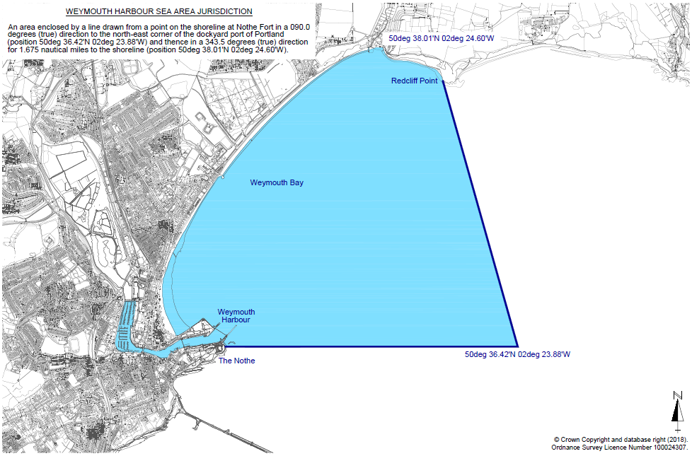
Figure 1: Weymouth Harbour Limits
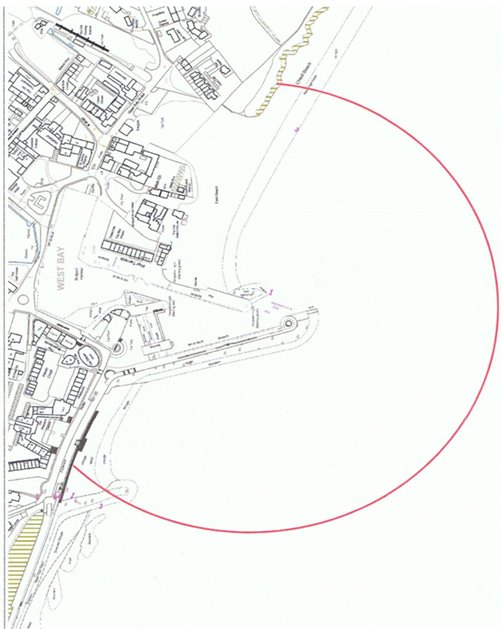
Figure 2: Bridport Harbour Limits

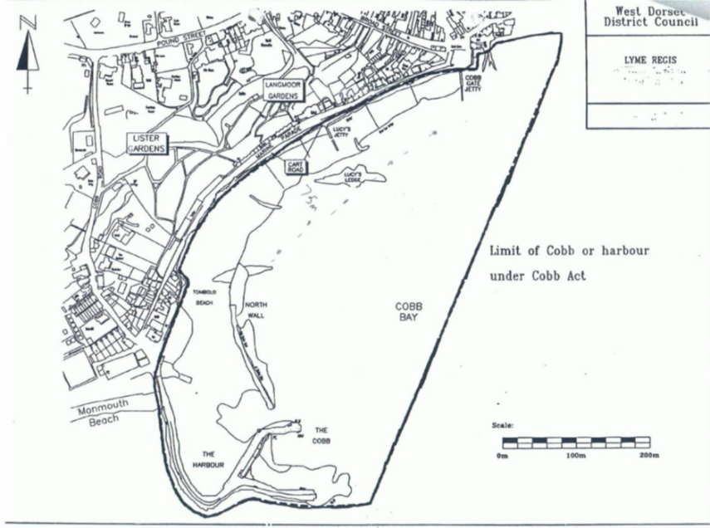
Figure 3: Lyme Regis Harbour Limits

